Location of new hospital in Zagreb

**Valentin Glas**

**April 13, 2020**

# **Introduction**

In past two weeks as can be seen in media, Zagreb had an earthquake and lot of Zagreb hospitals were damaged during this earthquake.[1][2] Even newborn babies were on morning cold in hospital yard. The main issue is that most of this hospital were built during late 19th and at the beginning of 20th Century. Next to this, most of hospitals are in city center. So many patients from suburb do not have hospitals In their district.

# Use of data

For this case I will use data from Wikipedia, where we can see Zagreb districts data in 2011. Next to this, I will use Foursqare data for geo locations of hospitals.

Here we can see data frame with latitude and longitude.

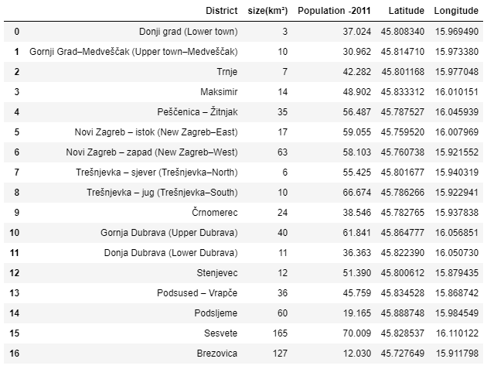

After data is imported next thing that we will do is folium map layout to see positions of Zagreb districts.

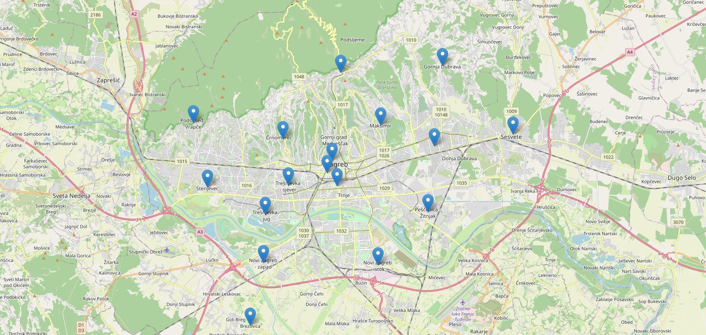

# Foursqare and locations of hospitals

Since, we need to visualize current location of hospitals we will useFoursqare. Commands that were used can be seen below.

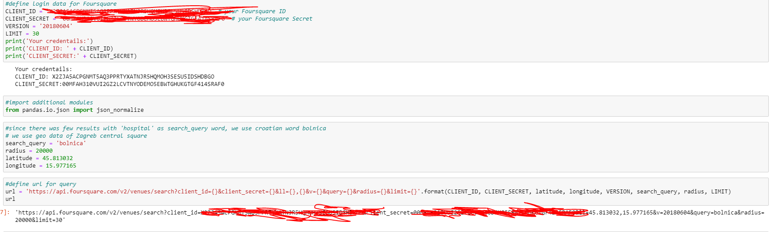

After the query we will get json data which need to be trimmed for next steps. Below can be seen first data frame which is from json data.

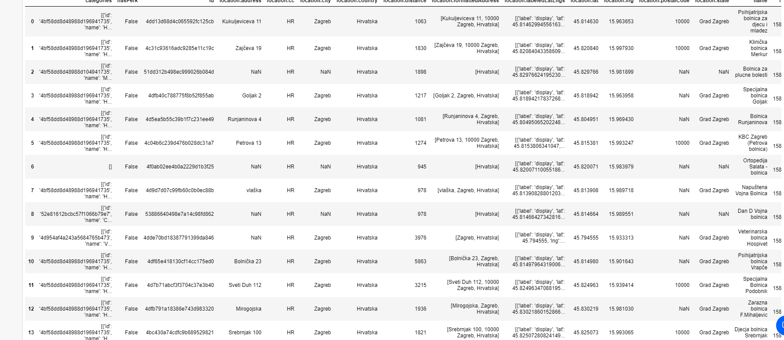

After filtering this data, we create new data frame with necessary columns.

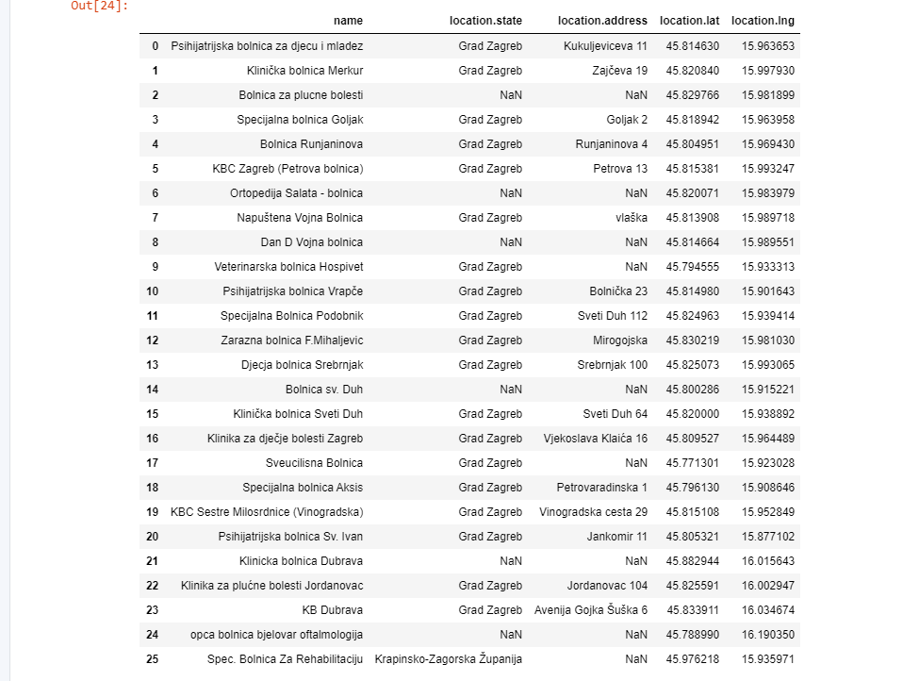

Since there was lot of data which is inaccurate, and does not refer to real world state, some of hospitals were deleted manually. Finally we get data frame which is reference to real state.

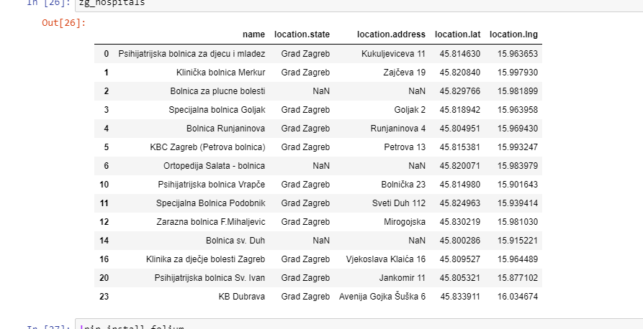

After we are done with trimming data, there is also provided folium map with current locations of hospitals.

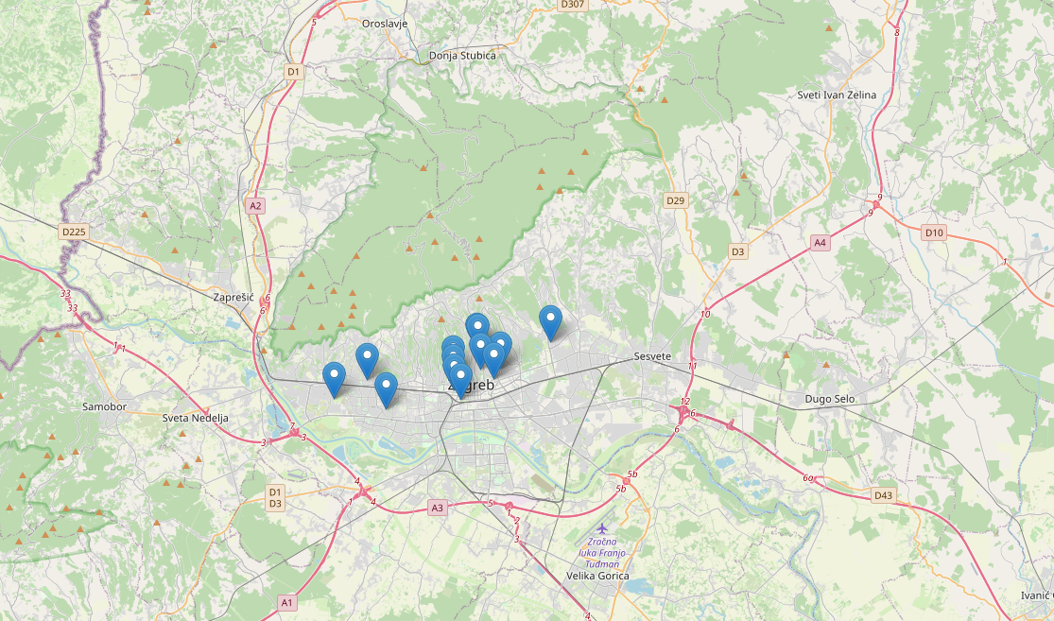

# Using SKM model to visualize clusters were are hospitals and districts

Since we begin project with statement that most of Zagreb hospitals are located in one place, that can be viewed using SKM model and Elbow curve method for number of clusters. Since there are two datasets, one with hospitals and other with districts. Below is shown visualization of these two different datasets.

Hospitals

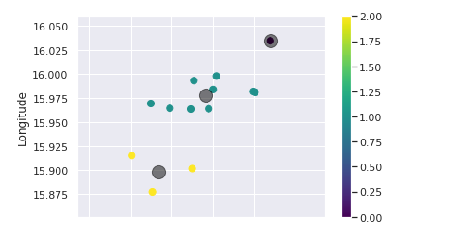

Districts

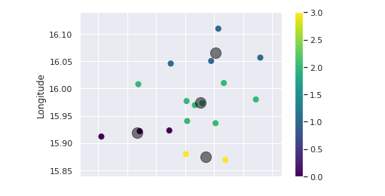

# Conclusion

As can be saw, most of the hospitals were built in City center and most of them are very close to each other. This is the reason why all of them were damaged in earthquake. Problem is that there is only one hospital in eastern part of city, and three in western. In addition to that, two these three are Psychiatric hospitals. So, the best way to overcome this is to build new hospital which will be in south-western part of city. Since most of citizens live there.

1. <https://en.wikipedia.org/wiki/2020_Zagreb_earthquake>
2. <https://www.independent.co.uk/news/world/europe/croatia-earthquake-today-zagreb-coronavirus-lockdown-maternity-hospital-a9416911.html>